LEXINGTON Kitchen Cupboard

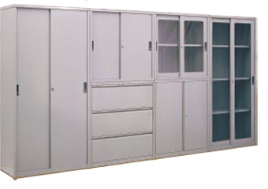

|  |
| --- |
| **DESCRIPTION** |
| LEXINGTON dream designing has introduced an extra wide wooden cupboard with slim door and open chest. The cupboard has a nice feel with smooth surface and a long chest for valuables. And the compartments which are present in the cupboard are many to hold products of large sizes. |

|  |  |  |
| --- | --- | --- |
| **Price** | **3250$** | |
| **Dimensions** | **H** x **W** x **L** | **60in x 22in x 80in** |
| **Features** | **There are four door shelves with two large and two small, two rotating selves, three opening draws and two glass shelves.** | |
| **Finished** | **White Wood** | |
| **Available in** | **Red and White** | |